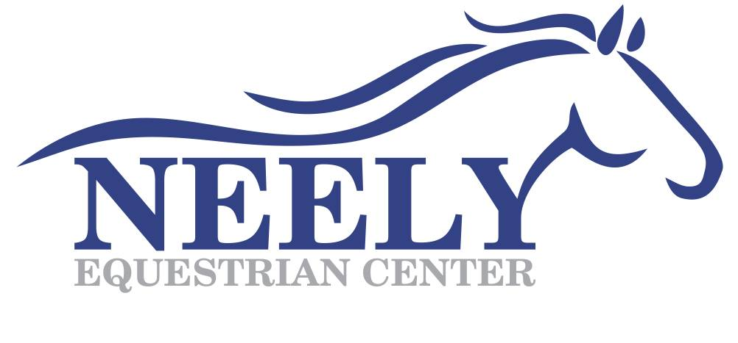

Photo Release Form
Date: __________________
I hereby grand to Neely Equestrian Center permission to use my likeness in photograph(s)/video in any and all of its publications and in any and all other media, whether now known or hereafter existing, controlled by Neely Equestrian Center, in perpetuity, and for other use by Neely Equestrian Center. I will make no monetary or other claim against Neely Equestrian Center for the use of the photograph(s)/video.

Full Name: __________________________________________________________________________
Signature: ___________________________________________________________________________
Relation to subject (if subject is a minor):___________________________________________________
Address: _____________________________________________________________________________
Phone Number: _______________________________________________________________________
Email: ______________________________________________________________________________

